**Phase 2: Practice Project: Assisted Practice: 1**

**Question: 02**

**Configure a servlet in Eclipse IDE.**

Step 1: Creating a dynamic web project

* Open Eclipse
* Go to the File menu. Choose New->Dynamic Web Project
* Enter the project name as FirstServlet. Click on Next
* Enter nothing in the next screen and click on Next
* Check the checkbox Generateweb**.**xmldeploymentdescriptor and click on Finish
* This will create the project files in the Project Explorer

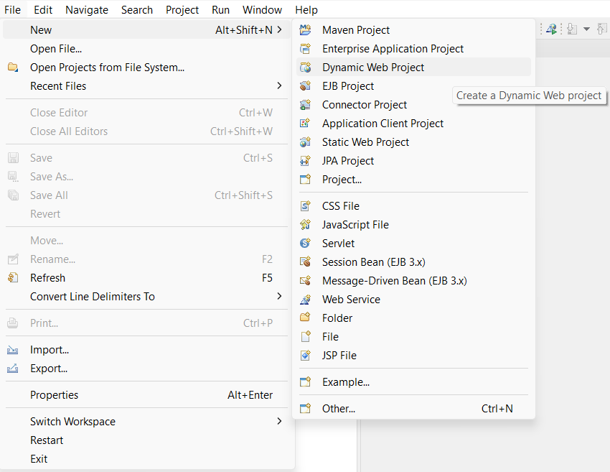

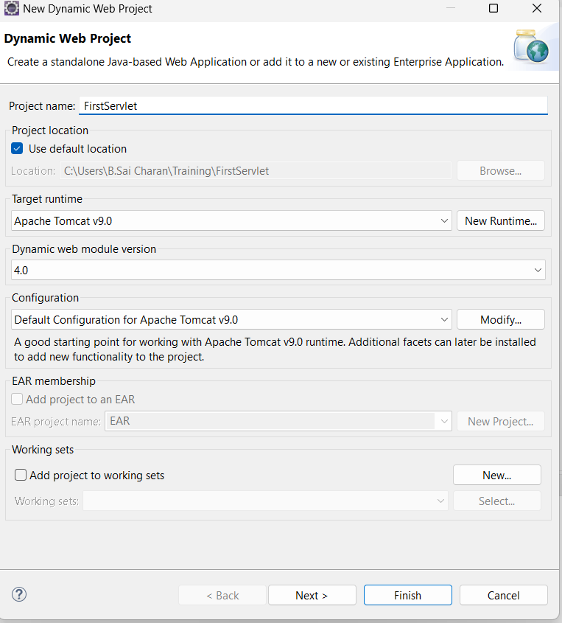

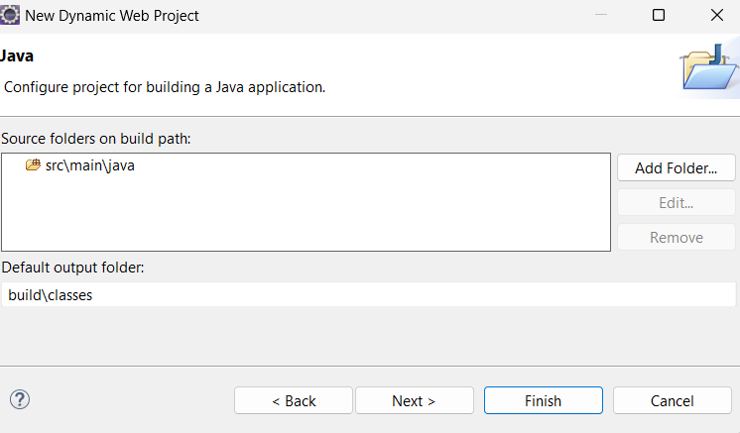

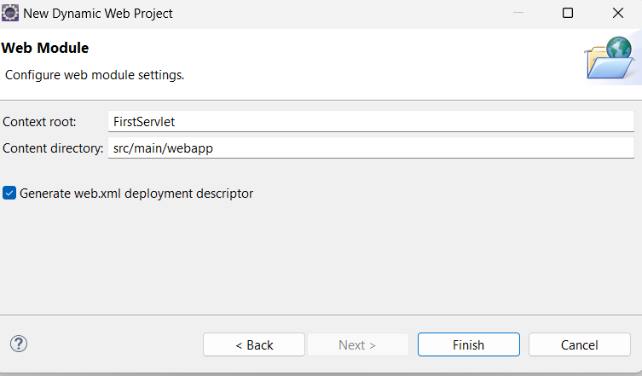

Step 2**:** Creating a servlet

* In the Project Explorer, expand ServletConcept->Java Resources
* Right click on src and choose New->Servlet
* In Class Name**,** enter FirstServlet and click on Finish

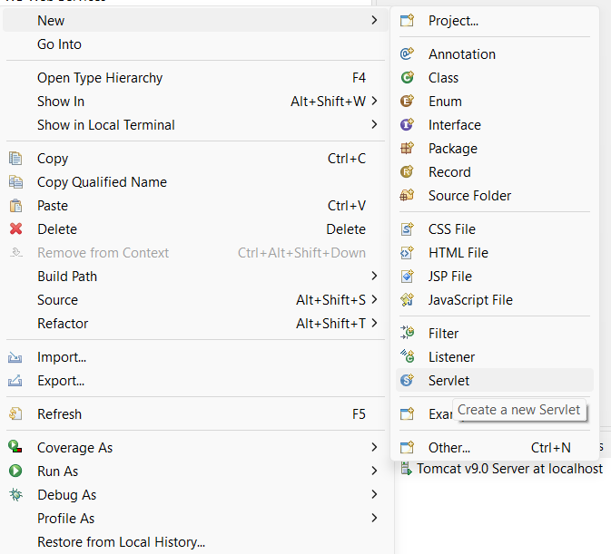

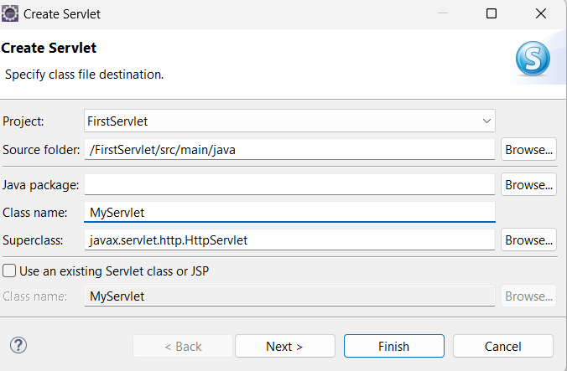

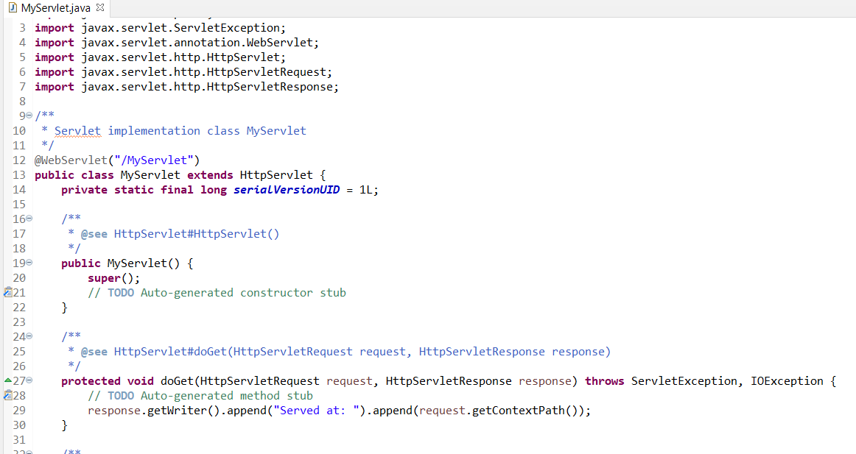

Step 3**:** Checking for servlet-api.jar

* Before building the project, we need to add servlet-api.jar to the project
* Servlet-api.jar file is already present in your practice lab. (Refer FSD: Lab Guide - Phase 2)
* To add it to the project, follow the below mentioned steps:
  + In the Project Explorer, right click on FirstServlet and choose Properties
  + Select Java Build Pathfrom the options on the left
  + Click on Librariestab on the right
  + Under ClassPath**,** expand the node that says Apache Tomcat
  + If there is an existing entry for servlet-api.jar, then click on Cancel and exit the window
  + If it is not there, then click on Classpathentry and click onAddExternal JARs button on the right
  + From the file list, select servlet-api.jar file and click Ok
  + Click on Apply and Close

Step 4**:** Running the project

* To run the project, open a web browser and type:
* [http://localhost:8080/MyServlet](http://localhost:8080/MyServlet%20)